**SER- Speech Emotion Recognition – Code**

# Load the drive helper and mount

from google.colab import drive

# This will prompt for authorization

drive.mount('/content/drive')

cd drive/'My Drive'/'Colab Notebooks'/'Emotion Speech Recognition'/

#Now above cell output is our path in which is in current working directory

!ls

#Provides a way of using operating system dependent functionality

import os

#LibROSA provides the audio analysis

import librosa

#Need to implicity import from librosa

import librosa.display

#Import the audio playback widget

import IPython.display as ipd

from IPython.display import Image

#Enable plot in notebook

%pylab inline

%matplotlib inline

import matplotlib.pyplot as plt

#This are generally useful to have around

import numpy as np

import pandas as pd

#To build neural network and desired model

import keras

from keras.models import Model

from keras.models import Sequential

from keras.layers import Conv1D, MaxPooling1D #,AveragePooling1D

from keras.layers import Flatten, Dropout, Activation #Input,

from keras.layers import Dense #,Embedding

from keras.utils import np_utils

from sklearn.preprocessing import LabelEncoder

data, sampling_rate = librosa.load('Dataset/surprise/surprise002.wav')

# To play audio this in the colab notebook

ipd.Audio('Dataset/surprise/surprise002.wav')

plt.figure(figsize=(15,5))

librosa.display.waveplot(data, sr=sampling_rate)

dataset_path = os.path.abspath('./Dataset')

destination_path = os.path.abspath('./')

# To shuffle the dataset records

randomize = True

# for splitting the dataset into training  and testing datasets

split = 0.8

# Number of samples per sec e.g 16KHz

sampling_rate = 20000

emotions=["anger","disgust","fear","happy","neutral","sad","surprise"]

#loading dataframes using dataset module

from utils import dataset

df, train_df, test_df = dataset.create_and_load_meta_csv_df(dataset_path, destination_path, randomize, split)

print('Dataset samples :', len(df),"\nTraining Samples : ", len(train_df),"\nTesting Samples :", len(test_df))

df.head()

print("Actual Audio : ", df['path'][0])

print("Labels : ", df['label'][0])

unique_labels = train_df.label.unique()

unique_labels.sort()

print("unique labels in emotion dataset : ")

print(*unique_labels, sep=', ')

unique_labels_counts = train_df.label.value_counts(sort=False)

print("\n\nCount of unique labels in Emotion dataset : ")

print(*unique_labels_counts, sep=', ')

#Histogram of the classes

plt.bar(unique_labels, unique_labels_counts, align= 'center', width=0.6, color='c')

plt.xlabel('Number of labels', fontsize=16)

plt.xticks(unique_labels)

plt.ylabel('Count of each labels', fontsize=16)

plt.title('Histogram of labels', fontsize=16)

plt.show()

from utils.feature_extraction import get_features_dataframe

from utils.feature_extraction import get_audio_features

trainfeature, trainlabel= get_features_dataframe(train_df, sampling_rate)

testfeature, testlabel= get_features_dataframe(test_df, sampling_rate)

#I have ran the above two lines to get featured dataframe and store it into pickle file for later purpose.it takes 30 mins approx to generate features.

trainfeatures = pd.read_pickle('./features_dataframe/trainfeatures')

trainlabel = pd.read_pickle('./features_dataframe/trainlabel')

testfeatures = pd.read_pickle('./features_dataframe/testfeatures')

testlabel = pd.read_pickle('./features_dataframe/testlabel')

trainfeatures.shape

trainfeatures = trainfeatures.fillna(0)

testfeatures = testfeatures.fillna(0)

# By using .ravel(): converting 1d to 2d e.g.(512,1) -> (512,).To prevent DataConversionWarning

x_train = np.array(trainfeatures)

y_train = np.array(trainlabel).ravel()

x_test = np.array(testfeatures)

y_test = np.array(testlabel).ravel()

y_train[:5]

# One-hot encoding

lb = LabelEncoder()

y_train = np_utils.to_categorical(lb.fit_transform(y_train))

y_test = np_utils.to_categorical(lb.fit_transform(y_test))

y_train[:5]

x_traincnn =np.expand_dims(x_train, axis=2)

x_testcnn= np.expand_dims(x_test, axis=2)

x_traincnn.shape

from tensorflow.keras import optimizers

optimizers.RMSprop()

model = Sequential()

model.add(Conv1D(256, 5,padding='same',

                 input_shape=(x_traincnn.shape[1],x_traincnn.shape[2])))

model.add(Activation('relu'))

model.add(Conv1D(128, 5,padding='same'))

model.add(Activation('relu'))

model.add(Dropout(0.1))

model.add(MaxPooling1D(pool_size=(8)))

model.add(Conv1D(128, 5,padding='same',))

model.add(Activation('relu'))

model.add(Conv1D(128, 5,padding='same',))

model.add(Activation('relu'))

model.add(Flatten())

model.add(Dense(y_train.shape[1]))

model.add(Activation('softmax'))

opt = keras.optimizers.RMSprop(lr=0.00001, decay=1e-6)

model.summary()

model.compile(loss='categorical_crossentropy', optimizer=opt,metrics=['accuracy'])

cnnhistory=model.fit(x_traincnn, y_train, batch_size=16, epochs=400, validation_data=(x_testcnn, y_test))

plt.plot(cnnhistory.history['loss'])

plt.plot(cnnhistory.history['val_loss'])

plt.title('model loss')

plt.ylabel('loss')

plt.xlabel('epoch')

plt.legend(['train', 'test'], loc='upper left')

plt.show()

model_name = 'Emotion_Voice_Detection_Model.h5'

save_dir = os.path.join(os.getcwd(), 'saved_models')

# Save model and weights

if not os.path.isdir(save_dir):

    os.makedirs(save_dir)

model_path = os.path.join(save_dir, model_name)

model.save(model_path)

print('Saved trained model at %s ' % model_path)

import json

model_json = model.to_json()

with open("model.json", "w") as json_file:

    json_file.write(model_json)

# loading json and creating model

from keras.models import model_from_json

json_file = open('model.json', 'r')

loaded_model_json = json_file.read()

json_file.close()

loaded_model = model_from_json(loaded_model_json)

# load weights into new model

loaded_model.load_weights("saved_models/Emotion_Voice_Detection_Model.h5")

print("Loaded model from disk")

# evaluate loaded model on test data

loaded_model.compile(loss='categorical_crossentropy', optimizer=opt, metrics=['accuracy'])

score = loaded_model.evaluate(x_testcnn, y_test, verbose=0)

print("%s: %.2f%%" % (loaded_model.metrics_names[1], score[1]*100))

preds = loaded_model.predict(x_testcnn,

                         batch_size=32,

                         verbose=1)

preds

preds1=preds.argmax(axis=1)

preds1

abc = preds1.astype(int).flatten()

predictions = (lb.inverse_transform((abc)))

preddf = pd.DataFrame({'predictedvalues': predictions})

preddf[:10]

actual=y_test.argmax(axis=1)

abc123 = actual.astype(int).flatten()

actualvalues = (lb.inverse_transform((abc123)))

actualdf = pd.DataFrame({'actualvalues': actualvalues})

actualdf[:10]

finaldf = actualdf.join(preddf)

finaldf[170:180]

finaldf.groupby('actualvalues').count()

finaldf.groupby('predictedvalues').count()

finaldf.to_csv('Predictions.csv', index=False)

demo_audio_path = './demo_audio2.wav'

demo_mfcc, demo_pitch, demo_mag, demo_chrom = get_audio_features(demo_audio_path,sampling_rate)

mfcc = pd.Series(demo_mfcc)

pit = pd.Series(demo_pitch)

mag = pd.Series(demo_mag)

C = pd.Series(demo_chrom)

demo_audio_features = pd.concat([mfcc,pit,mag,C],ignore_index=True)

demo_audio_features= np.expand_dims(demo_audio_features, axis=0)

demo_audio_features= np.expand_dims(demo_audio_features, axis=2)

demo_audio_features.shape

livepreds = loaded_model.predict(demo_audio_features,

                         batch_size=32,

                         verbose=1)

livepreds

# emotions=["anger","disgust","fear","happy","neutral", "sad", "surprise"]

index = livepreds.argmax(axis=1).item()

index

emotions[index]

**Screenshots**

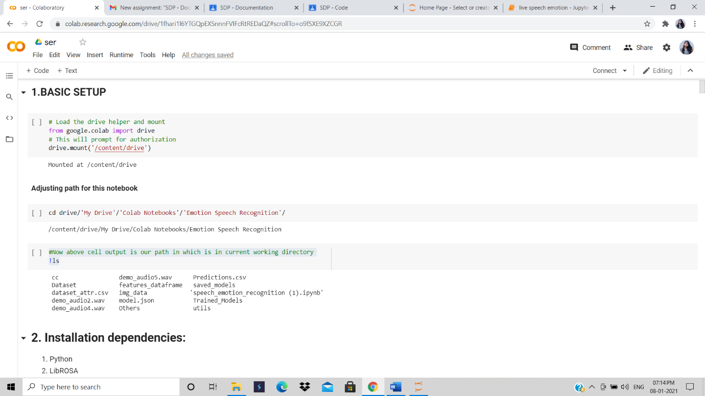

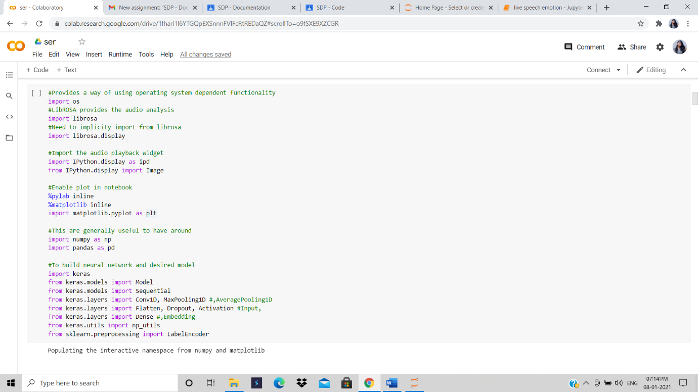

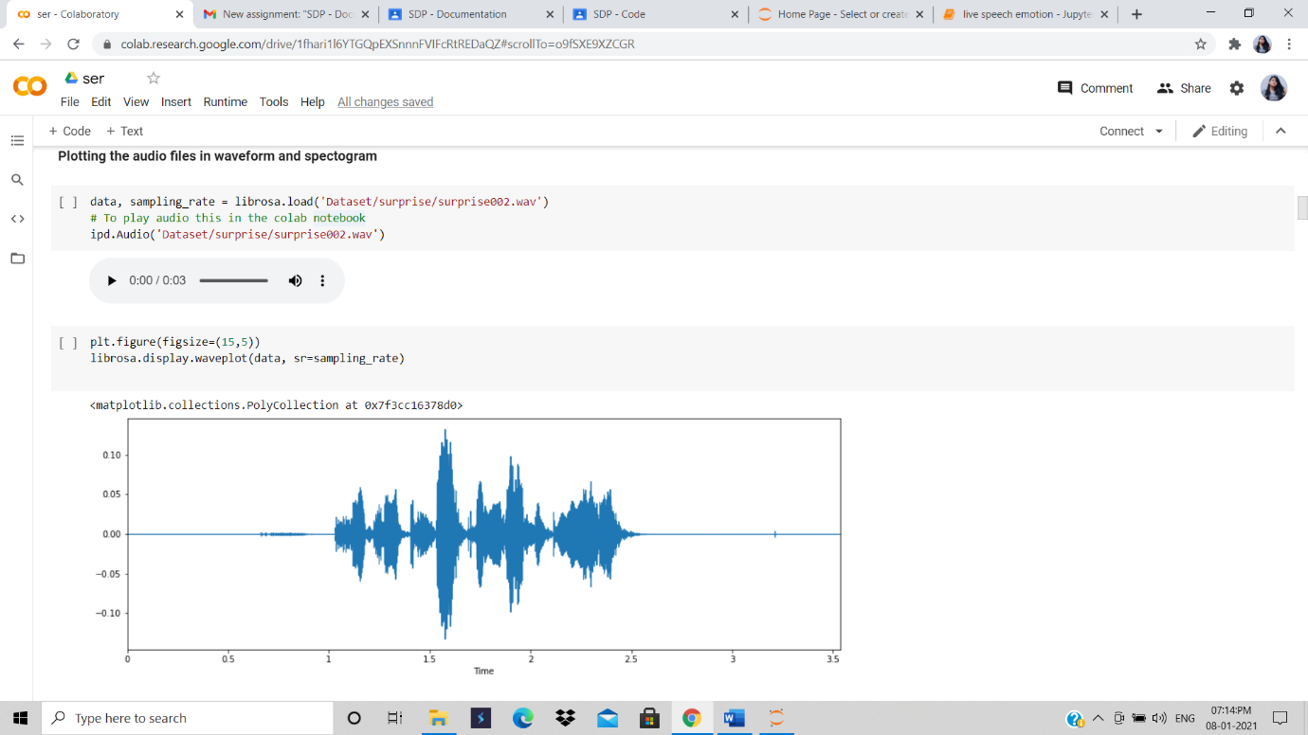

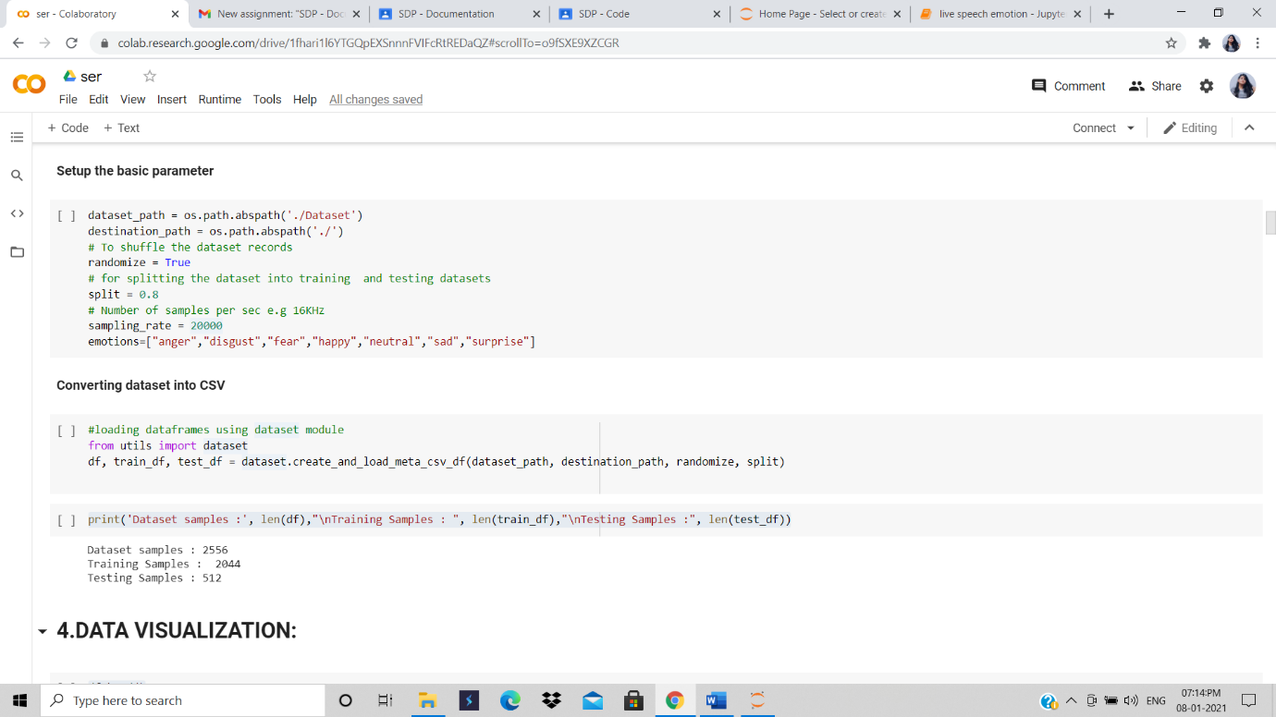

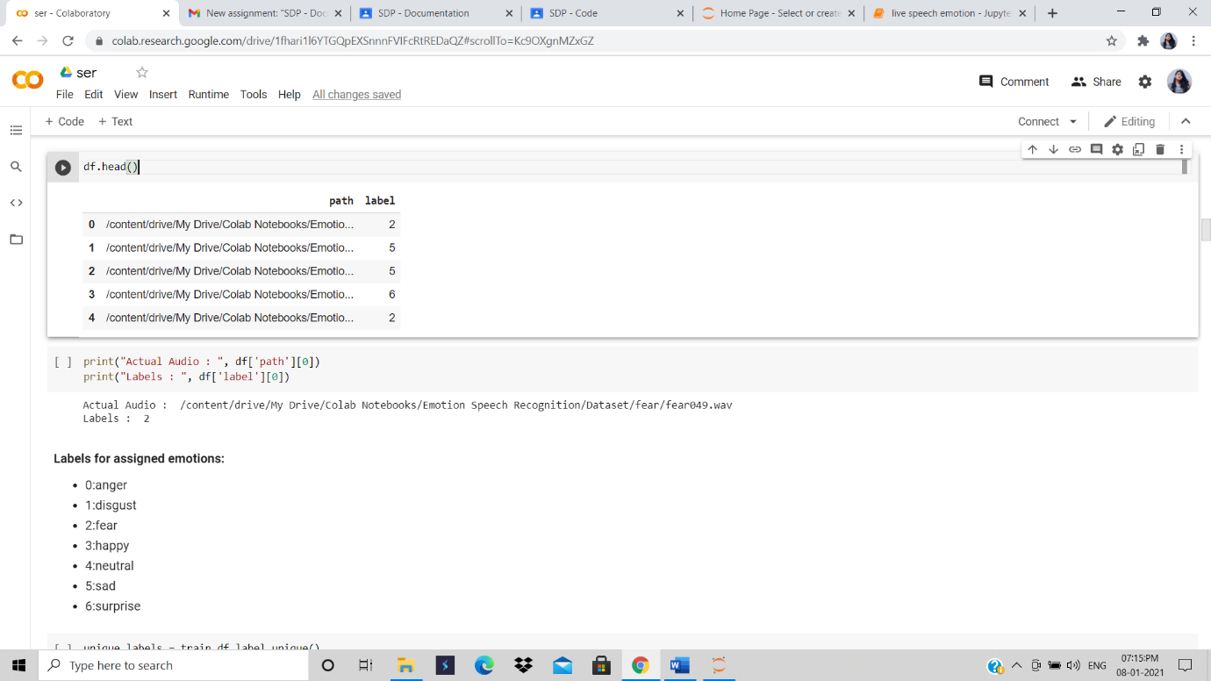

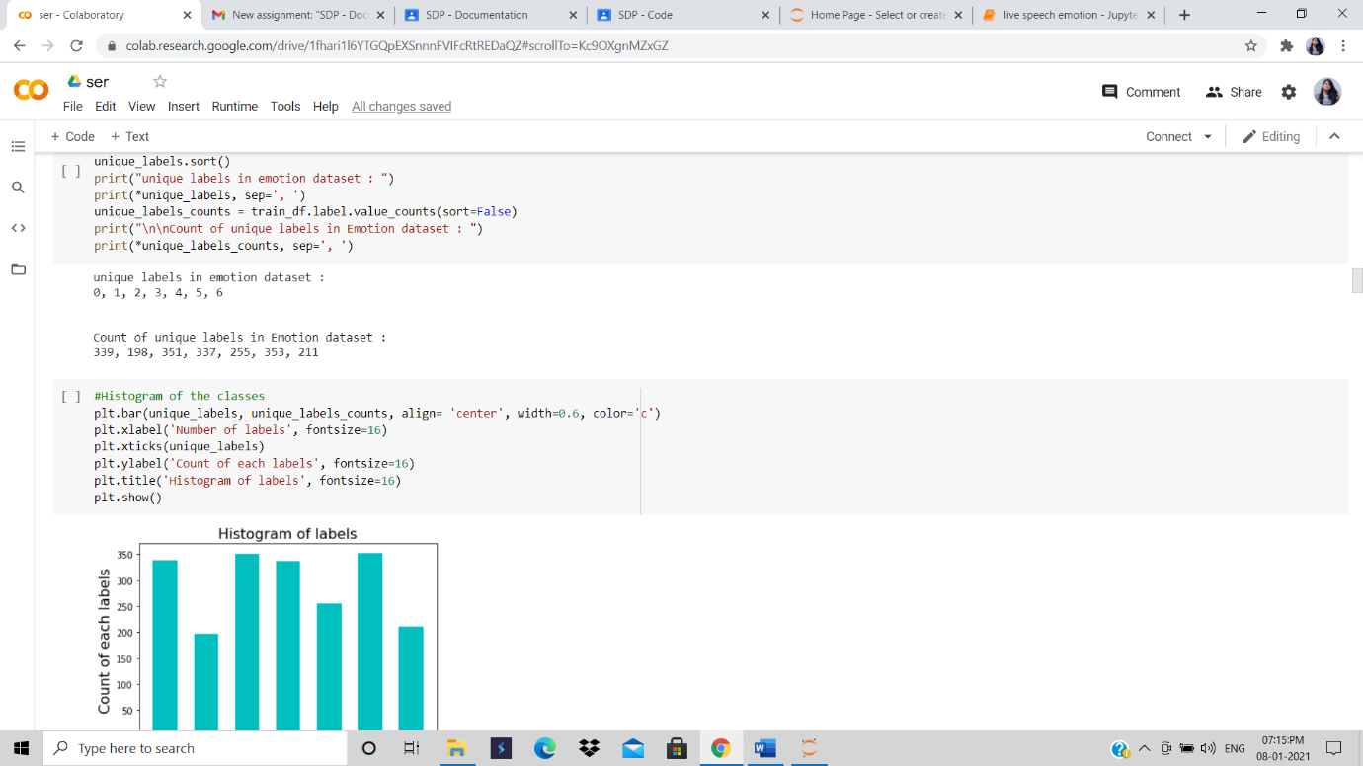

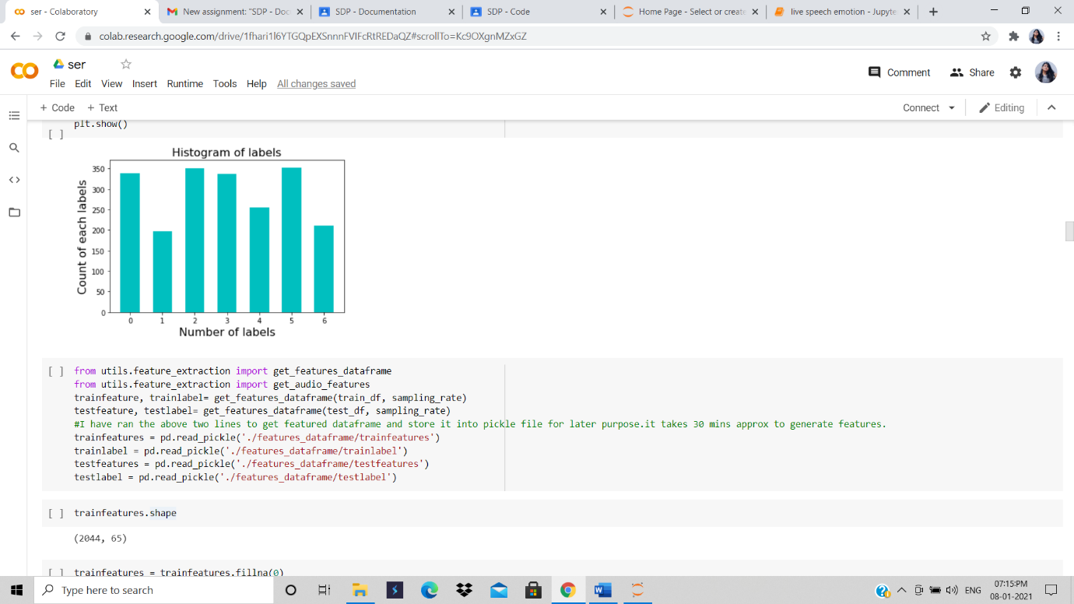

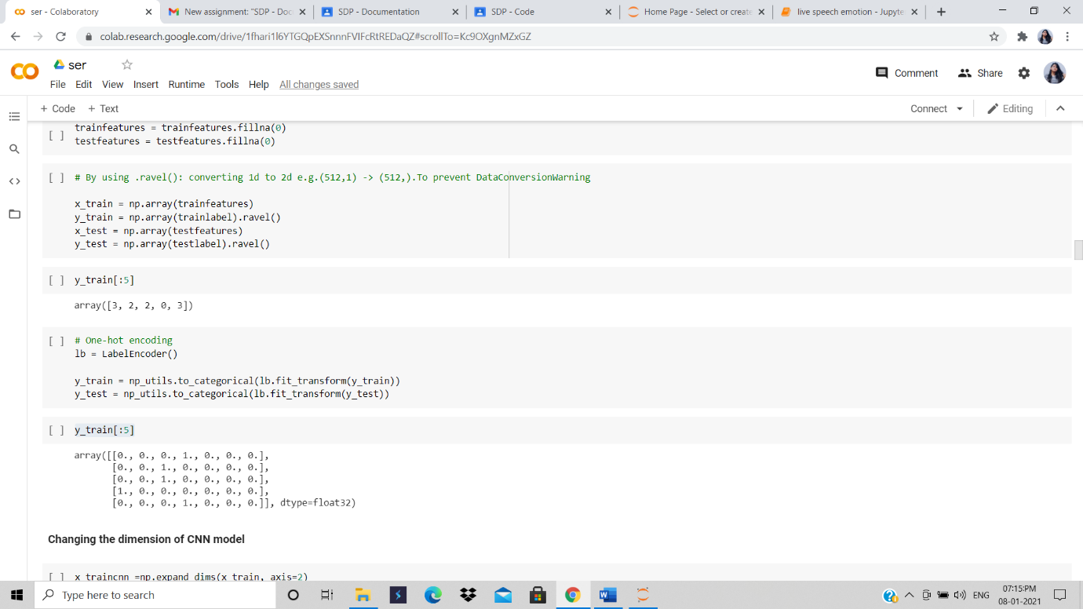

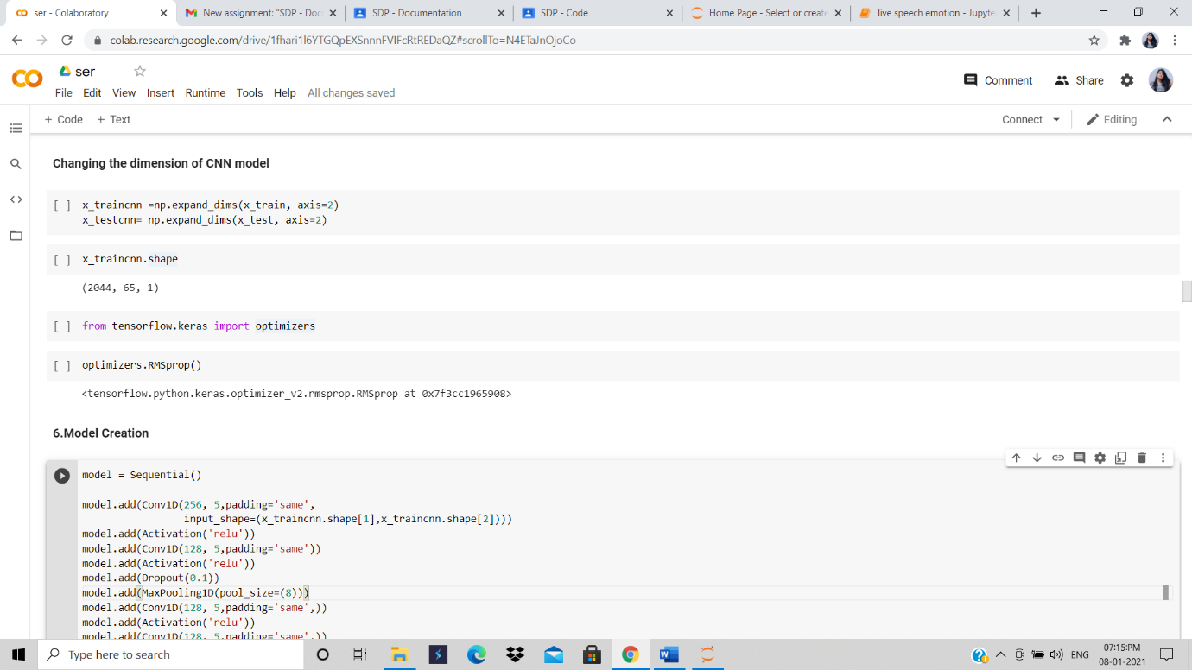

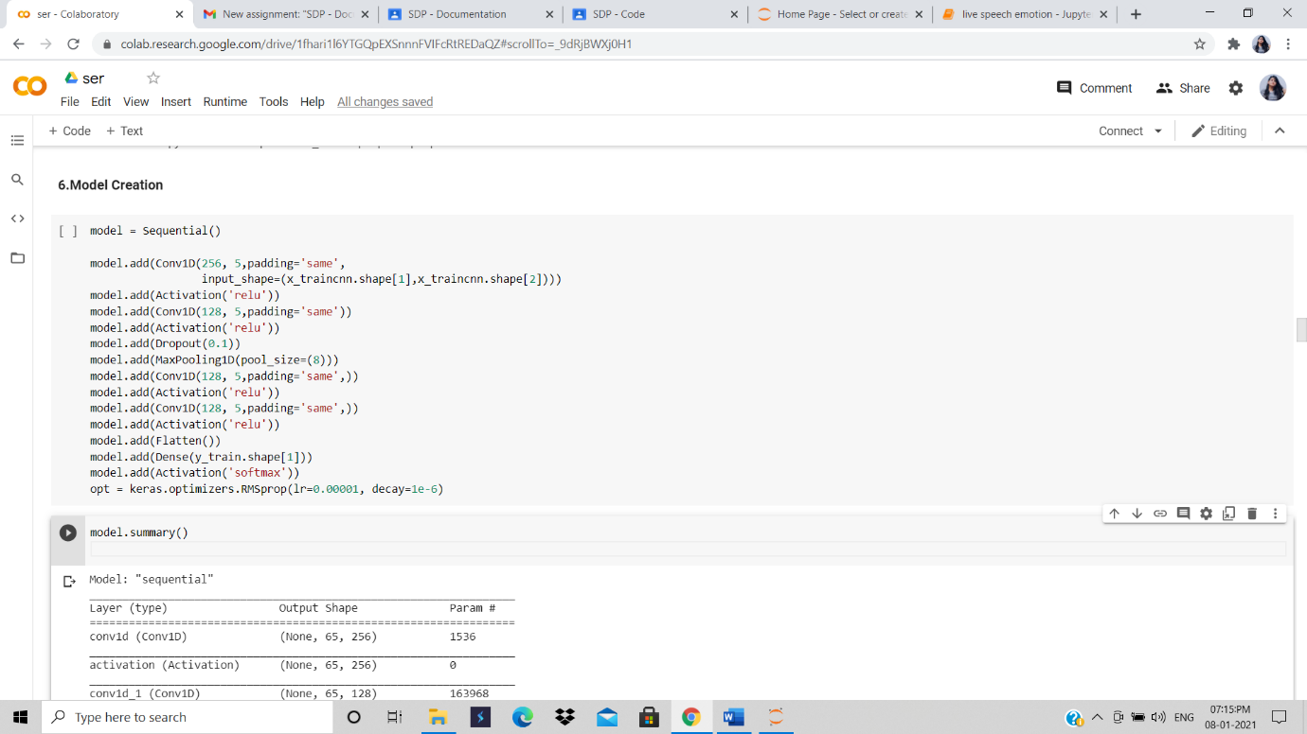

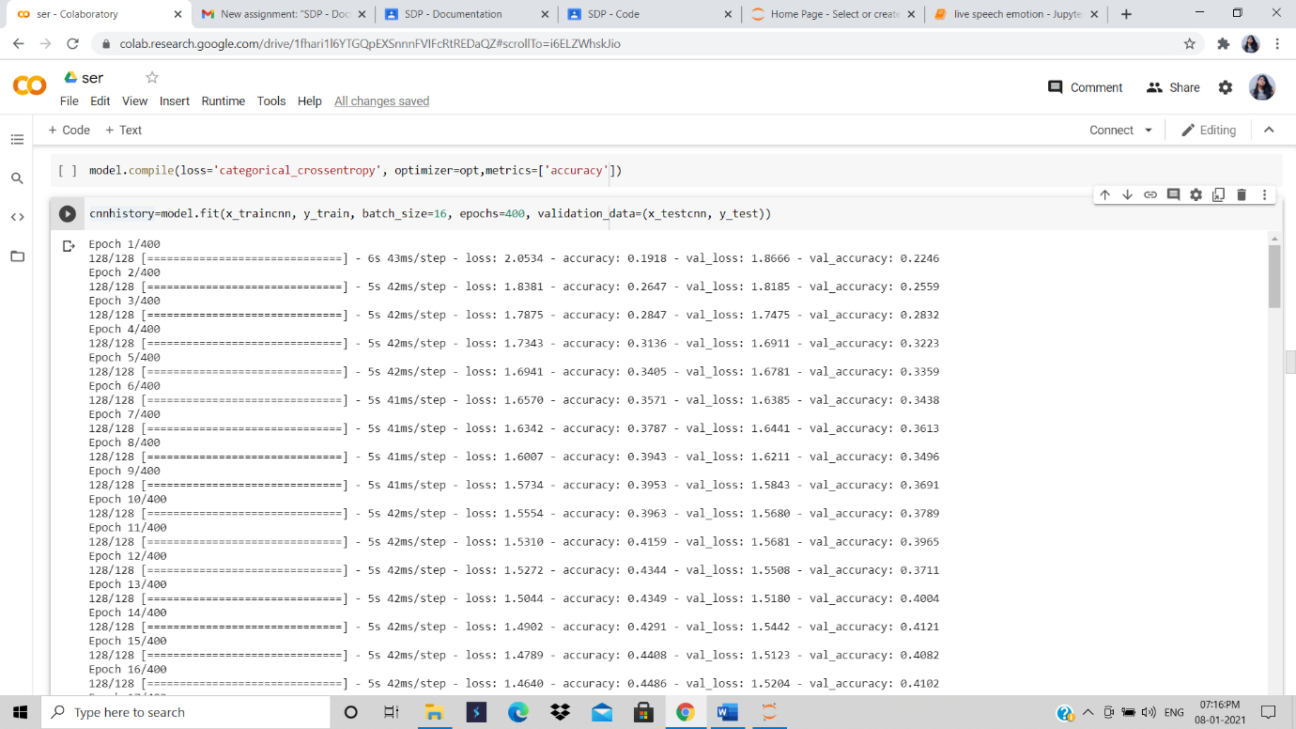

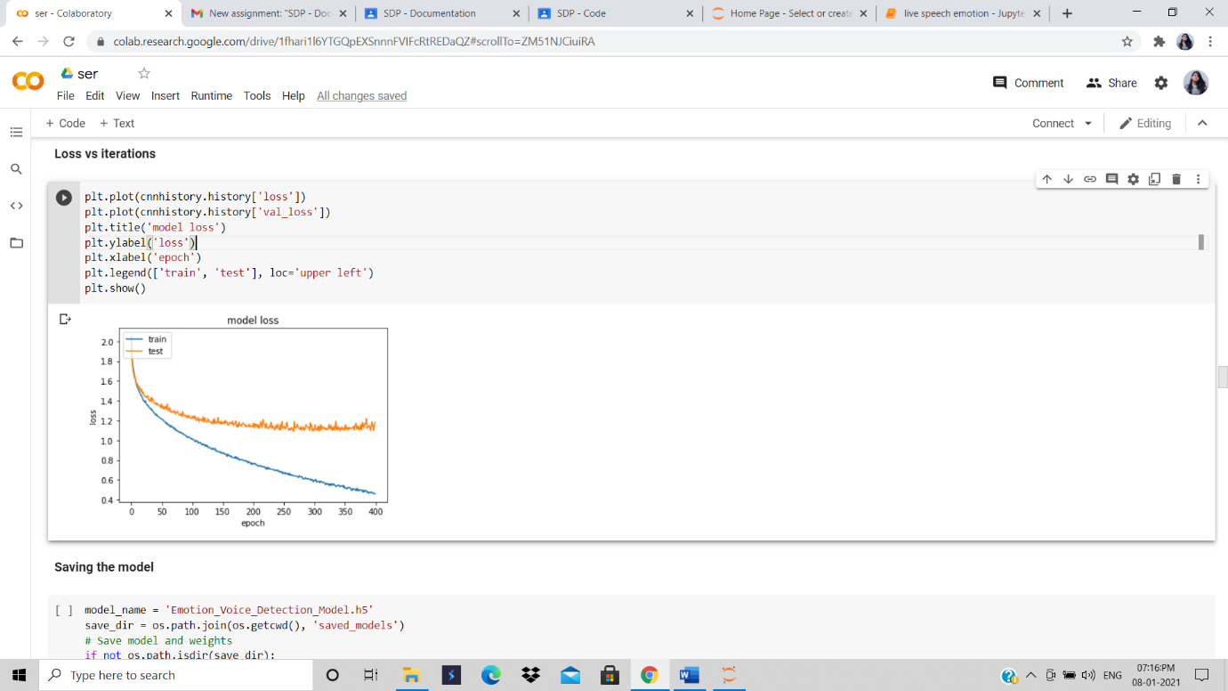

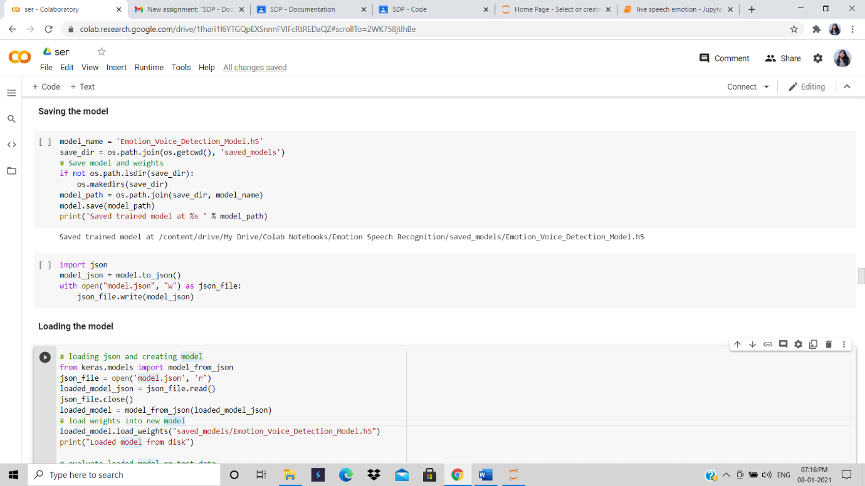

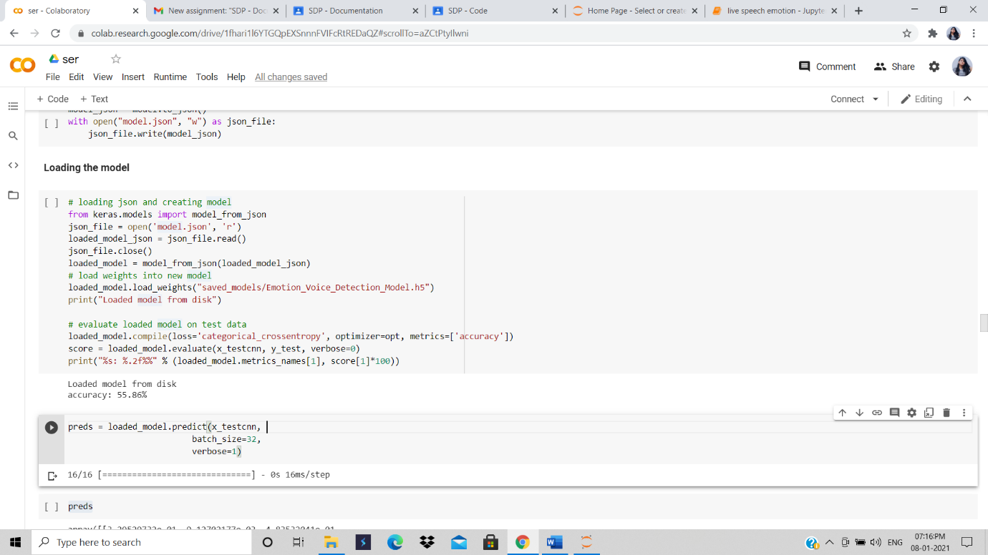

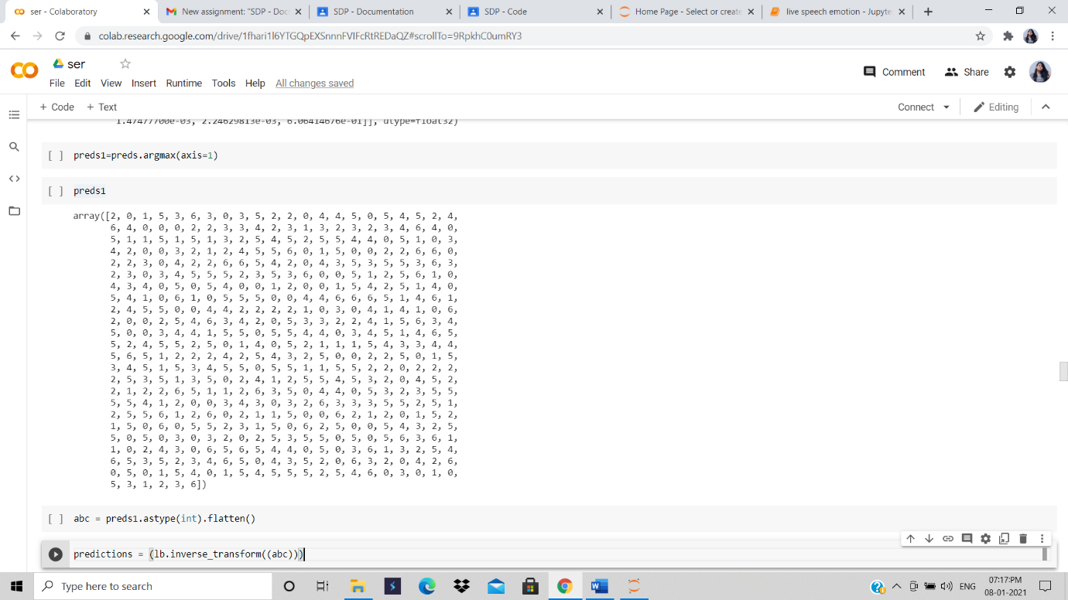

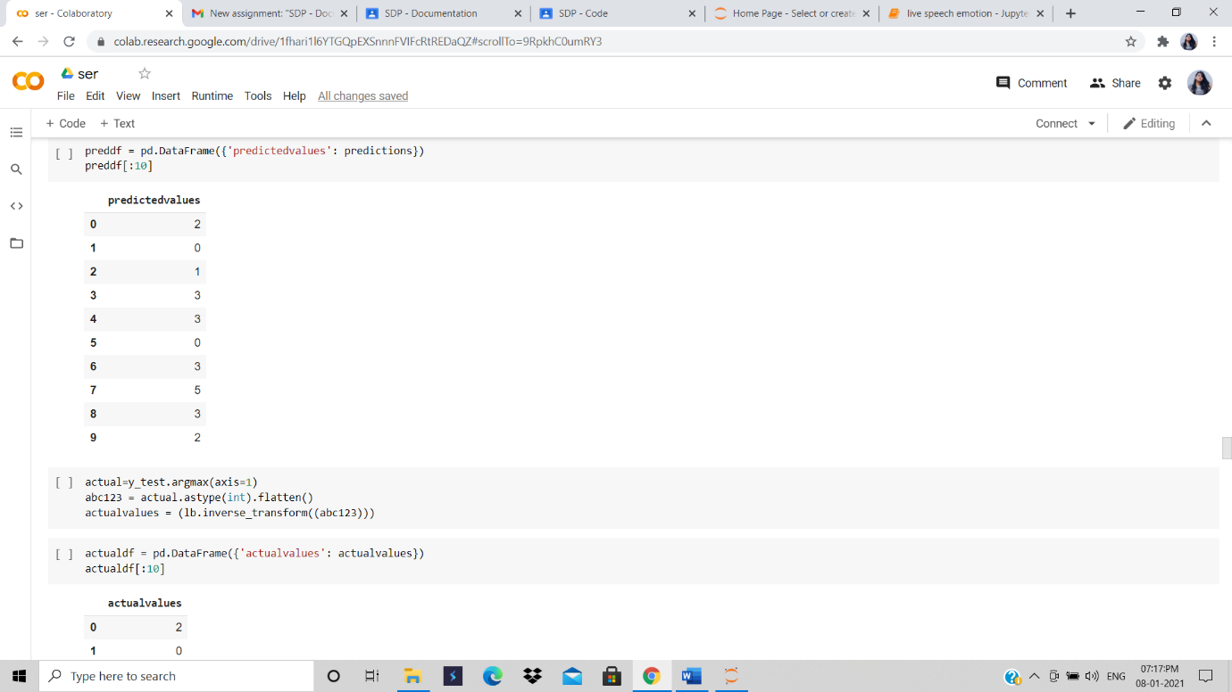

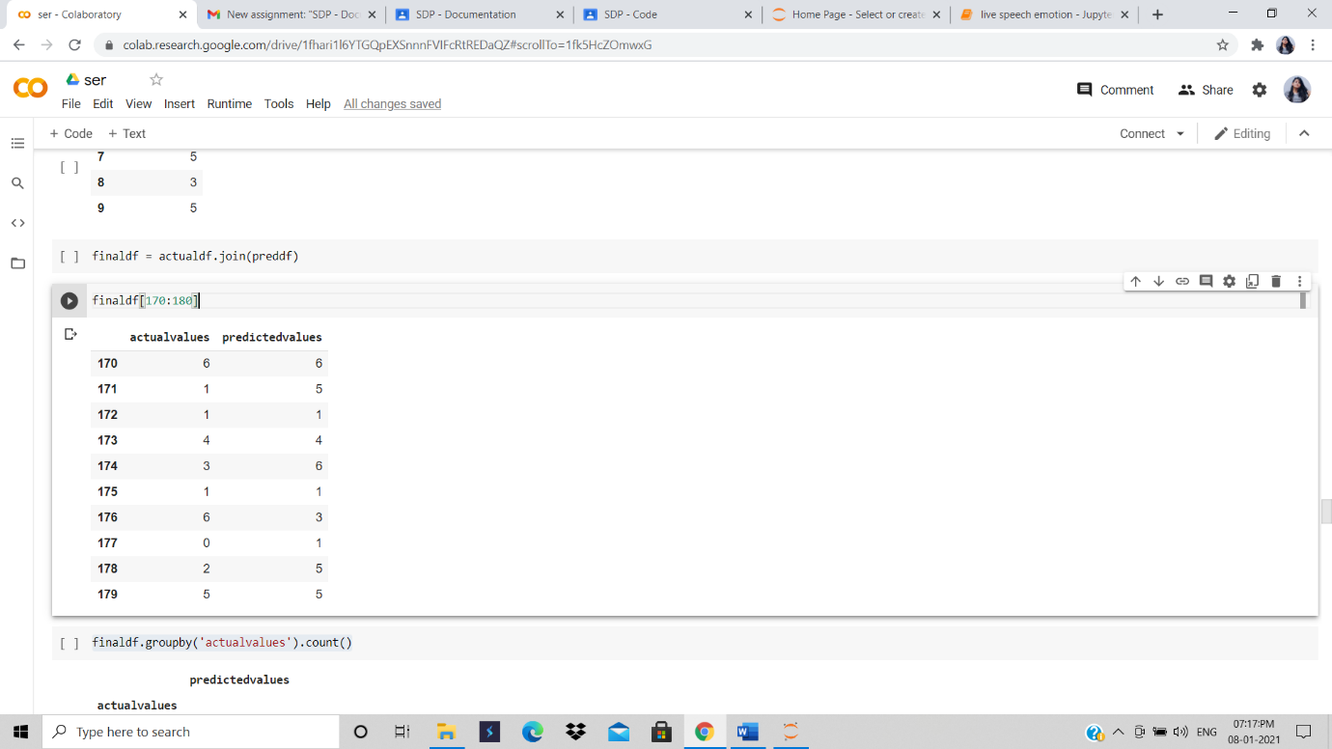

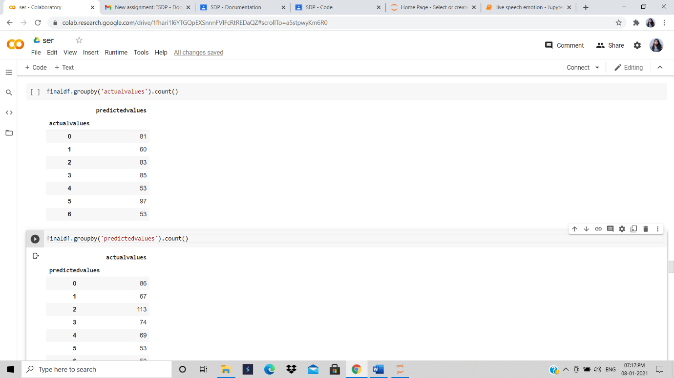

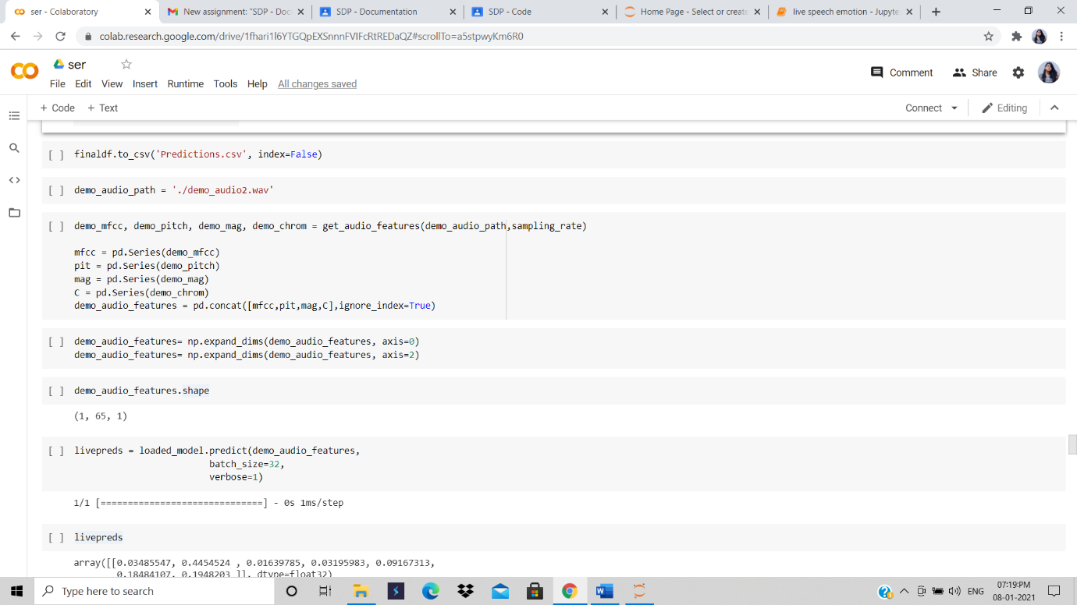

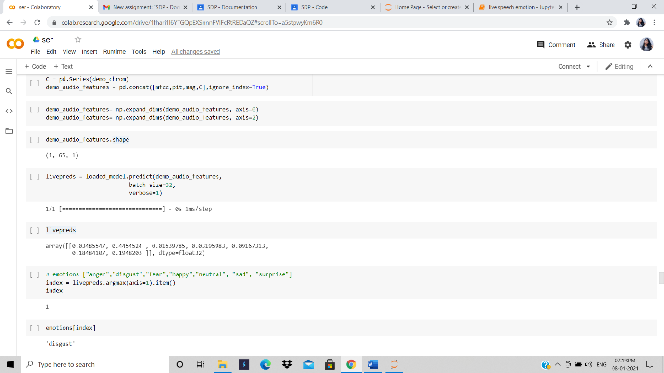

**Speech sentimental analysis- code**

import speech_recognition as sr

def recognize_speech_from_mic(recognizer, microphone):

# check that recognizer and microphone arguments are appropriate type

if not isinstance(recognizer, sr.Recognizer):

raise TypeError("`recognizer` must be `Recognizer` instance")

if not isinstance(microphone, sr.Microphone):

raise TypeError("`microphone` must be `Microphone` instance")

# adjust the recognizer sensitivity to ambient noise and record audio

# from the microphone

with microphone as source:

recognizer.adjust_for_ambient_noise(source) # # analyze the audio source for 1 second

audio = recognizer.listen(source)

# set up the response object

response = {

"success": True,

"error": None,

"transcription": None

}

# try recognizing the speech in the recording

# if a RequestError or UnknownValueError exception is caught,

# update the response object accordingly

try:

response["transcription"] = recognizer.recognize_google(audio)

except sr.RequestError:

# API was unreachable or unresponsive

response["success"] = False

response["error"] = "API unavailable/unresponsive"

except sr.UnknownValueError:

# speech was unintelligible

response["error"] = "Unable to recognize speech"

return response

recognizer = sr.Recognizer()

mic = sr.Microphone(device_index=1)

response = recognize_speech_from_mic(recognizer, mic)

print('\nSuccess : {}\nError : {}\n\nText from Speech\n{}\n\n{}' \

.format(response['success'],

response['error'],

'-'*17,

response['transcription']))

temp_str = ''

records_all = []

while (temp_str != 'bye'):

print('Speak it out')

response = recognize_speech_from_mic(recognizer, mic)

if response['success']:

temp_str = response['transcription']

print('You said :' ,temp_str )

if (temp_str != 'bye'):

records_all.append(temp_str)

print('Thanks for your suggetions')

print('Your suggetions on given product is:')

print(records_all)

from textblob import TextBlob

def get_sentiment(sentx):

'''

Utility function to classify sentiment of passed tweet

using textblob's sentiment method

'''

# create TextBlob object of passed text

analysis = TextBlob(sentx)

# set sentiment

if analysis.sentiment.polarity > 0:

return ('positive')

elif analysis.sentiment.polarity == 0:

return ('neutral')

else:

return ('negative')

# Select from collection

sentiments_total = {'neutral': 0 , 'positive' : 0 , 'negative':0}

for recd_sent in records_all:

sentiment = get_sentiment(recd_sent)

print (sentiment,'===>',recd_sent)

sentiments_total[sentiment] = sentiments_total[sentiment] + 1

print('###########################################')

print(sentiments_total)

from matplotlib import pyplot as plt

slices = [sentiments_total['neutral'],sentiments_total['positive'],sentiments_total['negative']]

activities = ['Neutral','Positive','Negative']

cols = ['c','m','r',]

plt.pie(slices,

labels=activities,

colors=cols,

shadow= True,

autopct='%1.1f%%')

plt.title('Sentiment Analysis of Voice')

plt.legend()

plt.show()

**Screenshots:**

